Joseph Silva Jr.

07/10/21

CS 340 – Assignment: 2

SNHU

**1.**

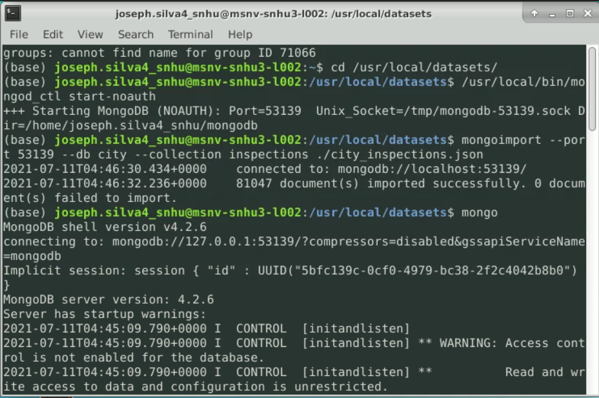

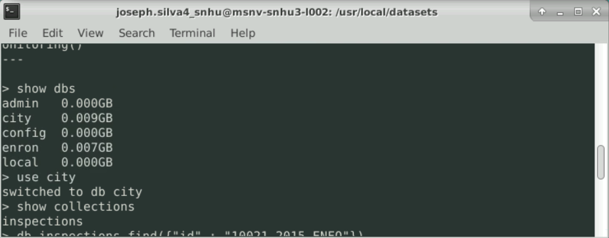

**2.**

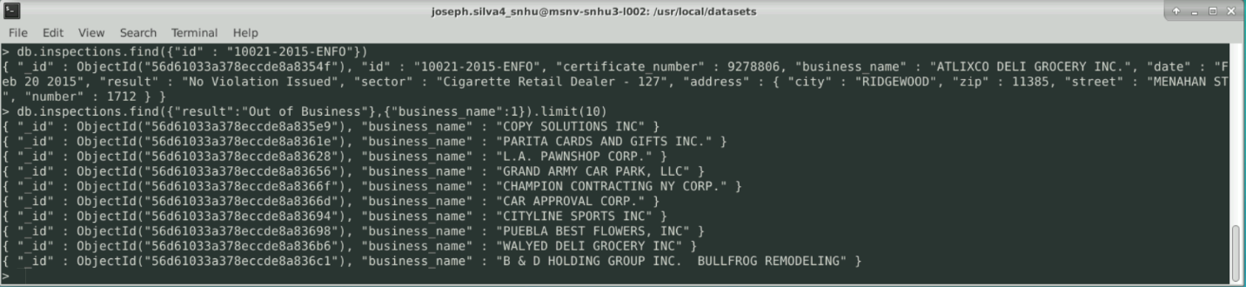

**3.**

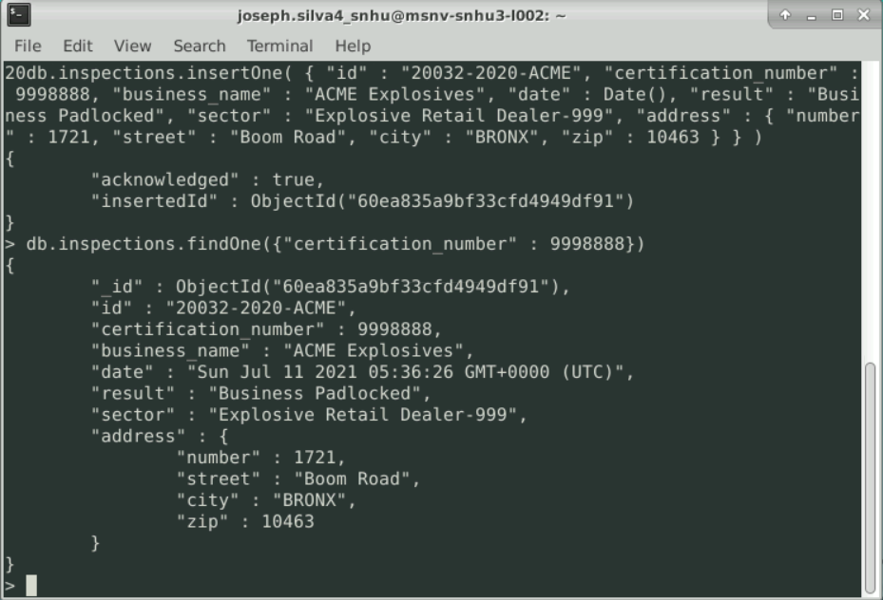

**4a.**

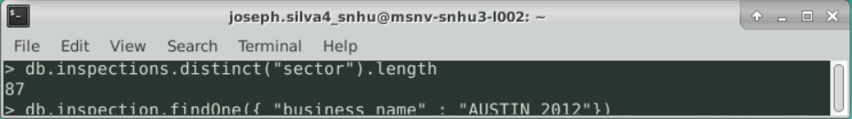

**4b.**

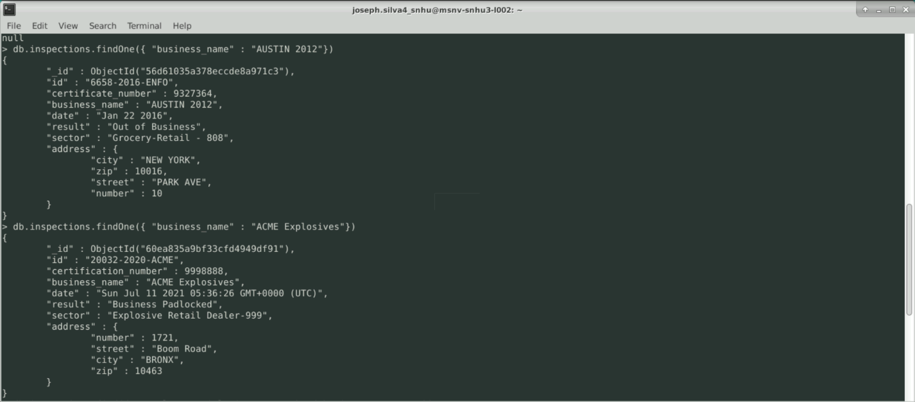

Austin 2012 date is month day and year.

ACME Explosives date is day of week, month, day, year, and time.

**4c.**

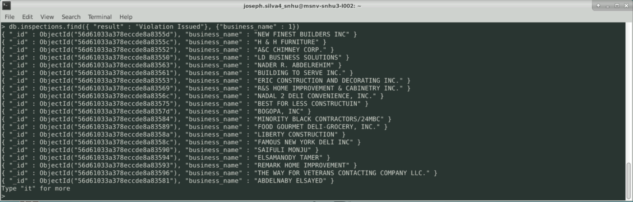

20 businesses have violation issued.

**5.**

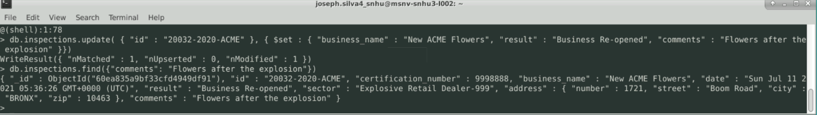

**6a.**

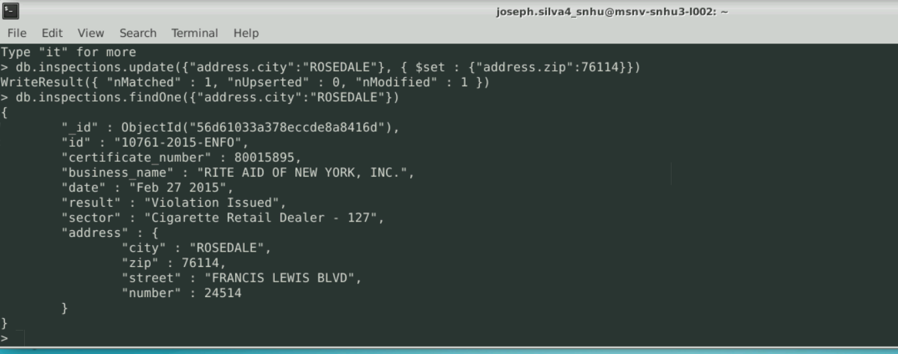

**6b**.

